Ribbon

The Ribbon is now common the common interface to Microsoft Windows 7, 2008 R2 and the Office tools, as expected this is now avalible in SharePoint 2010. The ribbon is contextual to the data you are viewing and icons are grayed out where no options are available or when no access is granted, when upgrading Content DB’s from MOSS 2007 you also have the option to keep the old visual interface (mainly there to help dev’s to fix and customization issues, once resolved the ribbon and new features can be enabled)

Attached are some examples of the Ribbon

**Page Default buttons**

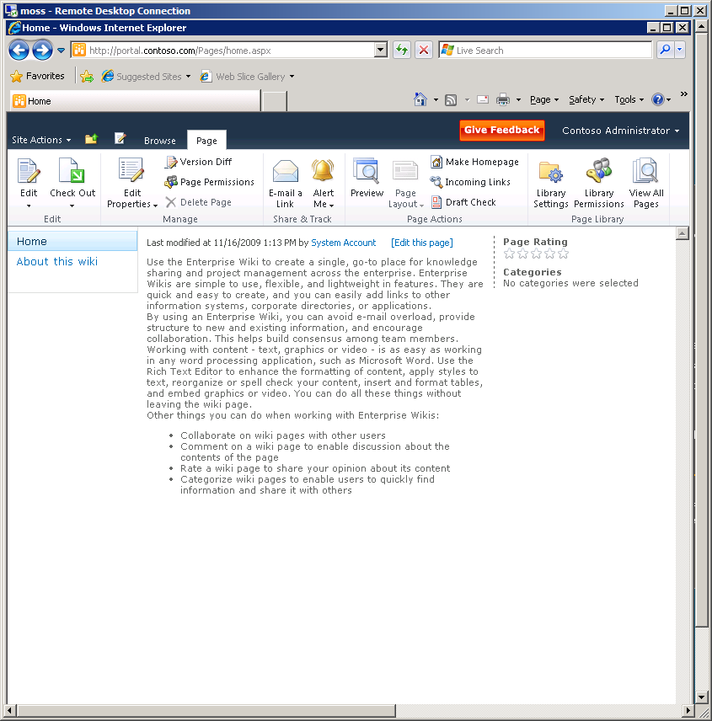

**Edit Page Default Buttons**

Format Text

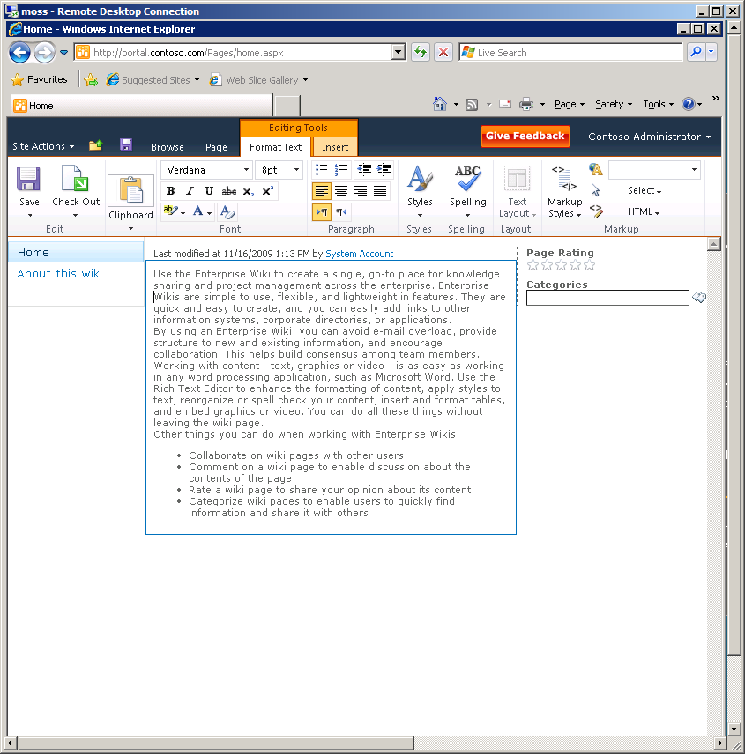

Insert

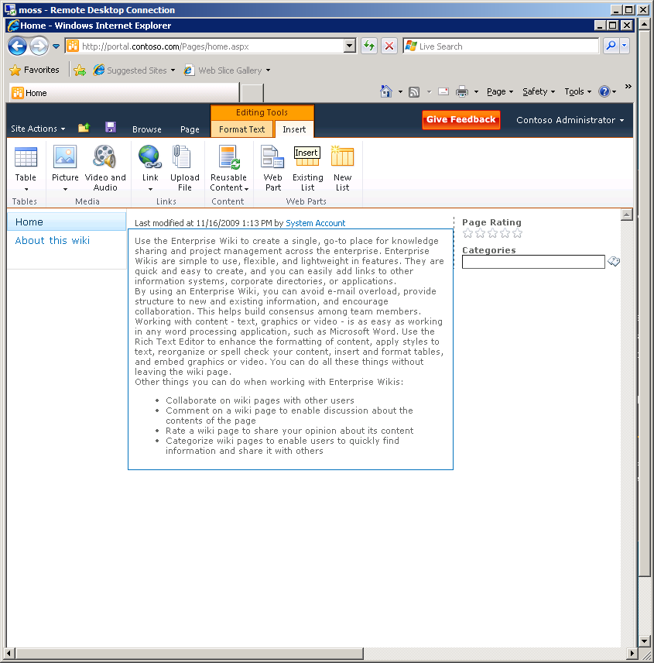

**Table Default Buttons**

Layout

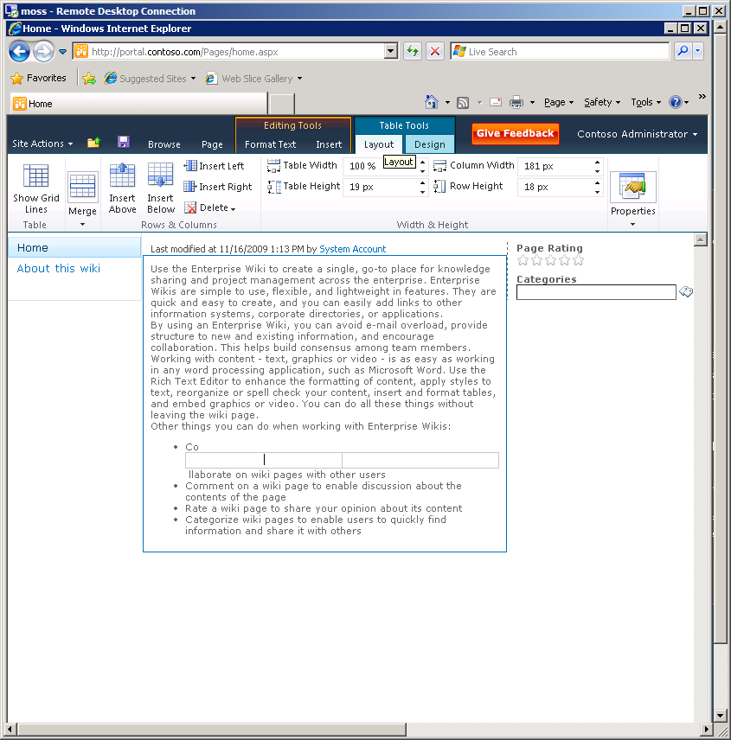

Design

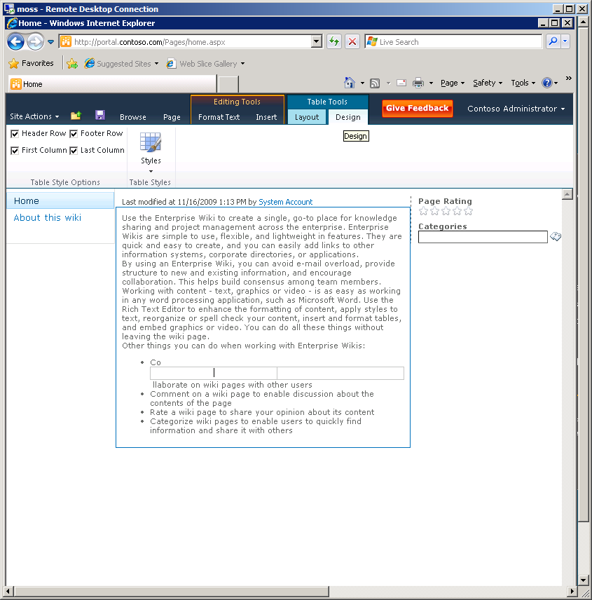

**Picture Default Buttons**

